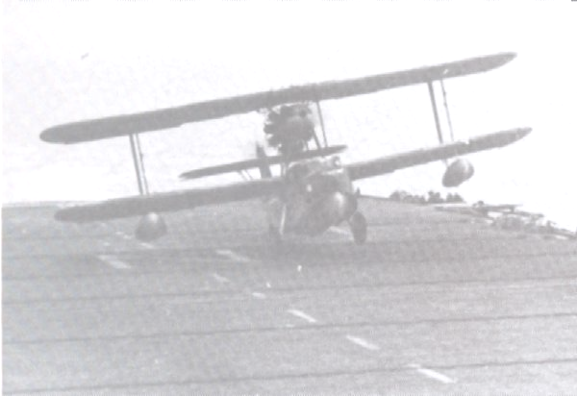

The John C. Robinson Mississippi Aviation Museum
Research Paper

Presented by:
Caitlin Bujnoch
Heather Buras
Luke Cochran
Robin Cochran
Alicia Dobson
Shara Tscheulin

MKT 650 - Dr. Beth LaFleur - Summer 2008

Table of Contents
Background for the Study……………………………………………………...………….3
Statement of Research Problem/Opportunities……………………………………………6
Justification of the Research………………………………………………………..……..6
Statement of Research Objectives/Questions………………………………….………….7
Research Design and Methodology for the Study…………………………...……………7
Findings……………………………………………………………………………….…..7
- Market Analysis/Target Market………………………………………………...…7
- Market Segmentation……………………………………………………….……..8
Figure 1. Average Annual Attendance………...……………………..……………9
Figure 2. Airline Passenger Activity at the Gulfport-Biloxi Airport…………….10
Figure 3. Breakdown of Tourists to the MS Gulf Coast….………………......….12
Figure 4. Military Affiliates on the MS Gulf Coast………..……...……………..15
- Market Potential……………………………………………………….…………16
Figure 5. Total Market Potential…………………………...…………………….16
- Market Needs…………………………………………………….………………17
- Market Trends……………………………………………………………………18
Start-Up Summary Explanation…………………………………………………...……..27
Figure 6. Front Elevation Phase 1 Picture………...……...……………………...28
Figure 7. Start-Up Cost……………………………………………..……………32
Financials…………………………………………………………………….…….…….32
Figure 8. Average Annual Revenues……..………………………………...……34
Figure 9. Large Scale Aviation Museums Average Annual Revenue.…..………34
Figure 10. Revenue Projections…………………………….………..…………..36
Figure 11. Average Annual Expenses………………………..……...…………...37
Figure 12. 12-Month Projected Costs.…………………………...…………..…..38
Figure 13. Annual Visitation Projections………...…………………..…………..39
Scope and Limitations………………………………………………………………..…..39
Conclusions…………………………………………………………………………...….40
References…………………………………………………………………..……………42

Background for the Study
The John C. Robinson Foundation (JCR Foundation) has put forth a proposal to the city of Gulfport, Mississippi to build an aviation museum in close proximity to the Gulfport-Biloxi International Airport. Initially, the museum was to be dedicated to John C. Robinson for his successful achievements; however, the focus has shifted into a Mississippi Aviation Museum that will encompass all of the states’ aviation achievements. In order to answer the questions posed by the JCR Foundation, extensive research was done on the museum industry. The museum research began with examining available literature resources and progressed to interviews with professionals who are knowledgeable in the field. The data was then analyzed and interpreted to form revenue and cost projections for the proposed museum.

The literature resources that were examined spanned the categories involving general museum information, museum publication, museum annual budget reports, general historical information on Mississippi aviators, Gulf Coast marketing data, target marketing data, and the proposal provided by the JCR Board of Directors.

Specific interviews were conducted with the following individuals: Stephen Watson, Dr. James Pat Smith and John McFarland. These interviews provided broad background information that was utilized throughout the research process. Stephen Watson, Vice President and Chief Operating Officer of the World War II Museum, was interviewed to gain knowledge pertaining to financial implications for the John C. Robinson Mississippi Aviation Museum (JCR Museum). This interview was conducted at the World War II Museum in New Orleans, LA. In the initial tour of this facility, Mr. Watson spoke of artifact and exhibit costs, the importance of the Board of Directors, collection of oral histories and the details involved in museum expansion. In the secondary portion of this interview, Mr. Watson emphasized specific costs involved in start-up funding, location details, gifting specifics and the importance of the target market.

Dr. James Pat Smith is a history professor at the University of Southern Mississippi and also a member of the JCR Board of Directors. Dr. Smith emphasized the desire to promote local aviation heroes as a way of inspiring future generations to excel. He spoke of general challenges faced by the Board of Directors and what obstacles are in the immediate future. Ultimately, an emphasis on education was stressed and the importance of developing an inspirational facility to meet this growing need.

An interview was also conducted with John McFarland. Mr. McFarland is the Director of Marketing at The Sun Herald, a local Mississippi newspaper. He provided key names of individuals in the Gulf Coast area that the Board of Directors could use as possible sources of information. These names are as follows: Tommy Simmons, a knowledgeable source about John C. Robinson; Bruce Frallic, Director of Gulfport-Biloxi International Airport; J. Pitts, Director of Marketing at Gulfport-Biloxi International Airport; Jerry Toronto, Director at Keesler Air Force Base and Base Commander.

The data gathered from both the literature resources and the specific interviews was then analyzed and interpreted to form revenue and cost projections for the proposed museum. To provide a more detailed projection and a better understanding of a museum in general, the following museums were contacted for phone and email interviews:
- The North Carolina Aviation Museum in Asheboro, NC
- The MS Armed Forces Museum at Camp Shelby in Camp Shelby, MS
- Beauvoir, The Jefferson Davis Home in Biloxi, MS
- The Ohr-O’Keefe Museum in Biloxi, MS
- The Walter Anderson Museum of Art in Ocean Springs, MS

Each museum’s director or employee was asked the following questions: number of visitors per year, the square footage of each facility, general admission prices and number of employees.

After reviewing numerous museums across the United States, appropriate comparisons for the future JCR Museum were found. The following museums were chosen due to their characteristics, such as square footage, location, proximity to an airport, city population size, operating budgets, and revenues earned.
- The Western Aerospace Museum in Oakland, CA
- The Hagerstown Aviation Museum, Inc. in Hagerstown, MD
- The Tennessee Museum of Aviation in Sevierville, TN
- The Southern Museum of Flight in Birmingham, AL

The following four museums were chosen from the local market.
- The Mississippi Armed Forces Museum at Camp Shelby
- The Ohr-O’Keefe Museum of Art in Biloxi, MS
- Beauvoir, the Jefferson Davis Home in Biloxi, MS
- The Walter Anderson Museum in Ocean Springs, MS

Statement of Research Problem/Opportunity
The Board of Directors of the JCR Foundation needs assistance projecting revenues and costs for the proposed museum They need to know if this project is feasible and approximately how much money needs to be raised to implement their plan. The main focus is to offer the board members precise estimates to help them determine the funding needed.

Justification for the Research
As an exploratory research project, heavy reliance was necessary on both academic literature and interviews. The academic portion was mainly derived from previous Form 990 tax documents from the selected museums. This provided the information necessary to make accurate estimates of cost and revenue projections. The interviews provided critical information into museum mechanics, relevant Gulf Coast statistical data and professional opinions. This provided cross comparison for the projections, as well as, general insight into the museum industry.

Statement of the Research Objectives/Questions
The questions that this research should answer are:
- What start-up costs, annual costs and annual revenues can the Board of Directors anticipate in the establishment of the JCR Museum?
- How does a museum operate as a non-profit entity?
- What form of target market exists on the Mississippi Gulf Coast?

Research Design and Methodology for the Study
This was an exploratory research project that utilized both interviews and literature reviews. Due to this process, much of the information gathered was qualitative in its nature. Specific markets of the Gulf Coast that were studied include tourism, student populations, veterans of the armed forces and current aviation affiliates. Financial data from museums across the United States was used for accurate projections to be made. Phone, personal and email interviews were conducted and used in projections and predictions.

Findings

Market Analysis/ Target Market

The target market that the JCR Museum will primarily focus marketing efforts on consists of tourists, or leisure travelers, including local and out-of-state visitors, specifically from the southeast region, with an average age of 50 years, having two children, as well as an average annual household income of around $61,800; veterans of the armed forces, especially those in aviation, with an average age of 78 years; schools, specifically on the Mississippi Gulf Coast; and organizations with Mississippi heritage or aviation affiliations.

Market Segmentation

After a thorough analysis of the various populations, opportunities, and trends that are encompassed in the Mississippi Gulf Coast tourism market, marketing efforts designed to attract potential visitors to the JCR Museum would prove to be most successful if they are specifically tailored to the precise needs of four distinct market segments. These four segments ultimately make up the target market for the museum. In order to determine which specific populations would be most appropriate to focus on, data was gathered to determine relevant demographic, psychographic, and geographic information about the populations, as well as perceived benefits and unique behavioral aspects, which contributed to the identification of the most appropriate target market.

The first market segment consists of tourists to the Mississippi Gulf Coast, which directly translates into those visitors who generally frequent various tourist attractions, museums, and parks in their travels. When assessing relevant aspects of tourism in regard to key characteristics of average museum patrons, national attendance to different types of museums should be considered. According to the American Association of Museum’s 2006 Financial Information Survey, the median annual attendance for different types of museums in the United States is broken down accordingly:

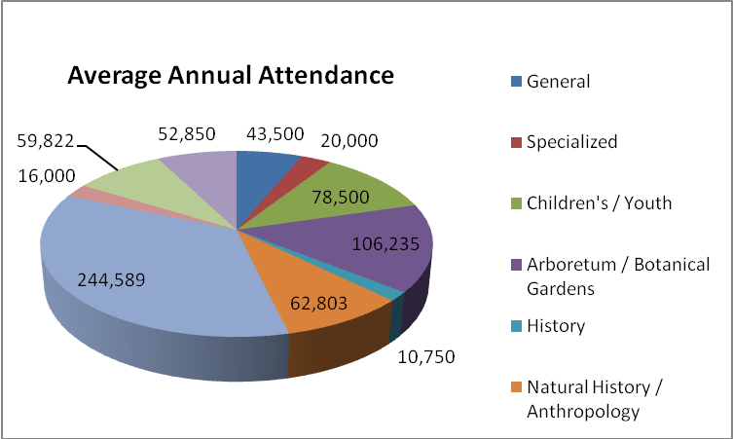

FIGURE 1.

Of the 17,500 total museums in the United States, the majority of museum patrons visited Science/ Technology museums, with an average of 244,589 visitors per year. If the proposed JCR museum chooses to expand its theme and subject matter to contain elements of not only John C. Robinson, but also encompass aspects of Mississippi aviation and space pioneering heritage as a whole, it will broaden its appeal to attract patrons of multiple types of museums, including visitors of general museums, history museums, specialized museums, science and technology museums, and possibly even Children’s/ Youth museums. (AAM, 2006)

An assessment of the Mississippi Gulf Coast market as a whole indicates that the current 2008 population for the three Mississippi Coast counties, including Hancock County, Harrison County and Jackson County, is 349,428 (J. McFarland, personal communication, July 22, 2008). In order to determine the number of individuals traveling by air to and from the Mississippi Gulf Coast, which is just one factor to consider in order estimating the number of out-of-state visitors, airline passenger activity at the Gulfport-Biloxi International Airport must be acknowledged.
FIGURE 2.
A measure of airline passenger activity at the Gulfport-Biloxi International Airport is a significant tourism indicator that should be recognized. When compared to population estimates, this is useful to gauge the amount of out-of-state or non-local visitors traveling to the Mississippi Gulf Coast by air. However, no distinction can be identified regarding the type and purpose of the trips the passengers are taking, making it impossible to estimate tourism projections solely based on this particular indicator alone. (J. McFarland, personal communication, July 22, 2008)

A “Mississippi Gulf Coast Visitor Profile” was also produced using information from TNS TravelAmerica Visitor Profile (July 2006-June 2007). (J. McFarland, personal communication, July 22, 2008)

The breakdown of relevant characteristics of visitors to the Mississippi Gulf Coast is as follows:
- There were 3.6 million visitors to the MS Gulf Coast in 2007.
  - 84% of trips, or 3,024,000, were leisure or personal trips.
  - 50% of those visitors traveling on leisure or personal trips, or 1,512,000 visitors, were casino patrons who saw gaming as the main attraction.
  - 85%, or 3,060,000, are overnight visitors.
  - 60%, or 2,160,000 visitors, stayed 1-3 nights.
  - $610 is the average expenditure of visitors during trip.
  - 50 is the average age of visitors.
  - $61,800 is the average income of visitors.
  - 80%, or 2,880,000 visitors, came in groups of two or more.
  - 20%, or 720,000 visitors, traveled with children.
    - 2.2 is the average number of children per family.
  - Modes of transportation: 76% auto, 9% air, 15% other (ie. Motorcoach).
  - The majority of out-of-state visitors came from the southeast region, from states such as Alabama, Florida, Louisiana, Georgia, Texas, North Carolina, Tennessee, and Arkansas.

Breakdown of Tourists to the Mississippi Gulf Coast
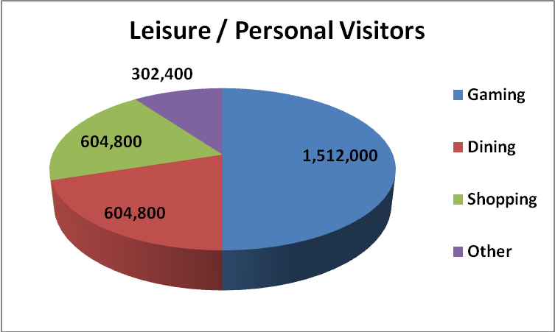
FIGURE 3.
The Visitor Profile determined that there were 3.6 million visitors to the Mississippi Gulf Coast in 2007 alone. Of the 3.6 million visitors, 84%, or 3,024,000 visitors’ trips, were found to be classified as leisure or personal trips, indicating these visitors frequent tourist attractions such as historic sites, parks, museums, and the like. Therefore, visitors traveling on leisure and personal trips will be the particular segment of tourists that the JCR Museum should tailor most of its marketing efforts toward. In addition, the 1,512,000 casino patrons, or 50% of the visitors traveling to the Mississippi Gulf Coast on leisure or personal trips, should not be excluded from marketing efforts altogether. They can also be considered as potential museum visitors in situations where they are searching for additional forms of entertainment to enhance their traveling experience, especially when they are traveling with family members, such as small children or elderly individuals. (J. McFarland, personal communication, July 22, 2008)
The second market segment that the JCR Museum should tailor marketing efforts toward consists of veterans of the armed forces. These veterans include 9,145 retired military veterans within a 50 mile radius of the Keesler Air Force Base, which encompasses Air National Guard retirees as well as retirees from all other branches of the armed forces. This segment also includes the 38,000 Tuskegee Airmen alumni and veterans of the Tuskegee Institute in Tuskegee, Alabama. Tuskegee veterans should also account for the 10,000 African Americans that served as flight instructors, officers, bombardiers, and many other positions over the years there and the 1,000 original Tuskegee Airmen, who are the first African American aviators. Both of these helped pave the way for the full racial integration of the United States military. (Tuskegee Airmen National Historic Site, 2008, p.2)

The third market segment that the JCR Museum will focus on addresses all of the schools on the Mississippi Gulf Coast. According to The Mississippi Department of Education (2006), the total potential market of students in Gulf Coast schools is 88,348, with teachers making up 4,724 additional visitors associated with school visits to museums. The public school sector includes 82,432 students and 4,347 teachers in public school zones, with a total of 161 public schools, an average number of 512 students per school, and an average number of 27 teachers per school. The private school sector, although much smaller in numbers than the public school sector, is generally more likely to provide funding to enable their students to take field trips to educational locations such as museums. The private school sector consists of 5,916 students and 377 teachers in private school zones, with a total of 29 private schools, an average number of 204 students per school, and an average number of 13 teachers per school. The JCR Museum should take advantage of the large number of schools and students in the Mississippi Gulf Coast region by specifically tailoring educational programs designed to appeal to children and younger audiences. This can be efficiently and effectively facilitated by marketing strategies such as group discounts, interactive exhibits, educational programs and museum tours. (The Mississippi Department of Education, 2006)

The fourth and final market segment that the JCR Museum will focus marketing and other efforts toward consists of affiliates of various organizations closely associated with the theme, subject, mission, or purpose of the museum. The Keesler Air Force Base is home to the 2nd Air Force, 403rd Air Wing (Air Force Reserve) and is the second largest Air Force medical facility. Keesler trains over 40,000 students annually, is the Coast’s single largest employer, and is the Electronics Training Center of Excellence for the U.S. Air Force. The Keesler Air Force Base had a $1,131,527,900 economic impact in 2007. There are currently 6,909 individuals on active duty with a payroll impact of $168,156,719 and 4,600 family members of active duty personnel present as well. There are also 3,396 civilian employees with a payroll impact of $158,217,438. Also included within this particular market segment is the Naval Construction Battalion Center in Gulfport, which currently employs over 4,500 people and has processed over 5,000 “Seabees” in 2007. Also in this market segment is Camp Shelby, which serves as a training site for the Air National Guardsmen and Reservists from throughout the country, hosting as many as 100,000 personnel annually. The camp population includes 350 active-duty members, 525 family members, 800 guards, 20 reserves, and 300 civilians. This segment also includes 500 Army personnel, 3,255 Navy and Marine Corps, 351 Coast Guard personnel, and 21,661 Reserve and National Guard personnel, which also includes the Mississippi Air National Guardsmen. The Air National Guard Combat Readiness Training Center at the Gulfport-Biloxi International Airport trained 20,000 Air Guard and Reserve in 2007. The final portion of this market segment consists of the variety of affiliates of the John C. Stennis NASA Space Center, where there is an average of 4,500 employees at the Stennis location on the Mississippi Gulf Coast per year; with a workforce mix consisting of an average of 35.85%, or about 101 female employees and an average of 64.15%, or about 180 male employees (Thebald, 2007, p.1). The breakdown of affiliate numbers is as follows:

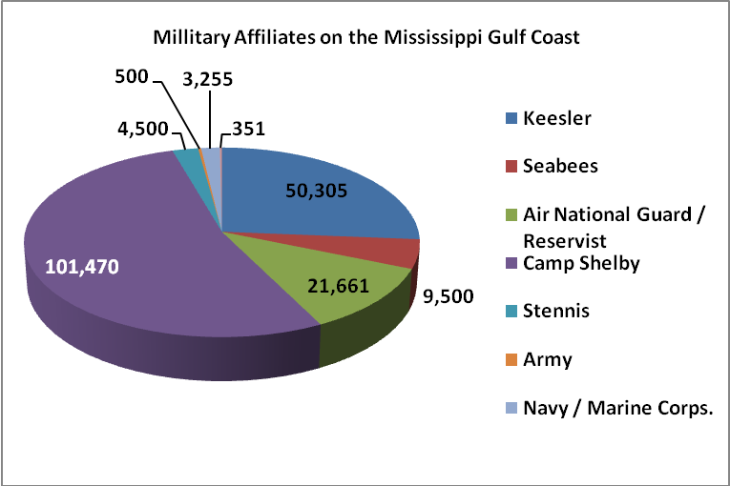

FIGURE 4.

Market Potential

Total Market Potential
MS GC Tourists
Gaming | 1,512,000
Shopping | 604,800
Dining | 604,800
Other | 302,400
Veterans
Retired Military | 9,145
Tuskegee Airmen Alumni | 38,000
Schools
Students | 88,348
Teachers | 4,724
Affiliates
Keesler | 46,909
Seabees | 9,500
Air National Guard / Reserve | 21,661
JC Stennis / NASA | 4,500
Camp Shelby | 101,470
Army | 500
Navy/ Marine Corp. | 3,255
Coast Guard | 351
Market Potential | 3,352,363
Visitor Multiplier X2 (Veterans/ Affiliates) | 235,291
TOTAL Market Potential | 3,587,654

FIGURE 5.

After assessing the populations of each of the previously mentioned target market segments, totals were concluded to estimate the market potential for the JCR museum. This total was then multiplied by a visitor multiplier of two, assuming that each visitor will not come alone, but instead visit the museum with an average of one other guest not accounted for in the previously mentioned market segments. The total market potential of 3,587,654 includes these guests as well. The museum’s goal will be to tailor marketing efforts to reach the maximum amount of individuals as possible in this potential market of 3,587,654 individuals.

Market Needs
The Mississippi Gulf Coast “…is the 3rd largest gaming center in the nation and growing steadily as a regional destination for travelers looking for multiple casino-resort offerings” (J. McFarland, personal communication, July 22, 2008). The Gulf Coast is home to countless tourist attractions, including museums ranging from historical homes such as Beauvoir, art galleries like the Ohr-O’Keefe Museum of Art and the Walter Anderson Museum of Art, and various military museums such as the Armed Forces Museum at Camp Shelby and the G.I. Museum in Ocean Springs. Other tourist attractions include eleven casinos, the John C. Stennis NASA Space Center and the associated INFINITY Science Center which will attract a significant amount of international visitors, an entire coastline of beaches, and a 20 course, $20 million dollar golf industry. The Gulfport-Biloxi Metro Area ranks 9th on the Forbes List of Top 10 fastest-growing small metro areas. It is estimated that the metro area could grow by 23% by 2012, and the population could increase by 17%. The current 11,500 room inventory on the Mississippi Gulf Coast will need to grow to at least 35,000 in order to accommodate the growing number of tourists traveling to this region. (J. McFarland, personal communication, July 22, 2008)

Although the Mississippi Gulf Coast is a well-developed destination tourist market, there is a growing need for more diverse attractions that appeal to a wider population, such as families with children and cultural tourists seeking educational experiences. In addition, Hurricane Katrina destroyed a large amount of museums and other tourist attractions along the Gulf Coast, leaving many communities in need of preserving and presenting artifacts and histories of Mississippi’s history and cultural heritage. Given the enormous amount of local interest in aviation and the growth rate and potential of the Mississippi Gulf Coast, there is a significant growing market base for the JCR Museum. Over 50,000 volunteers have come from around the nation to aid in the ongoing hurricane relief efforts as well. All of these relevant aspects contribute to an immense opportunity for the JCR Museum to be successful in establishing potential donors, appealing to its target market, and achieving a large number of visitors on an annual basis. (J. McFarland, personal communication, July 22, 2008)

Market Trends
Market trends in the museum industry focus on such key areas as museum management, collections stewardship, education, marketing, public relations, development, and fundraising, with an emphasis on technology at the forefront of this industry evolution. Recent technological advances are creating and facilitating new methods of exhibiting museum artifacts and materials to the public.

LCD’s and digital plasmas are no longer the superior value-adding distinction of museum industry technology; they are now considered basic elements of standard museum design and build. The new trend in the museum industry is the general focus on scientific questioning. “The exhibit builder who is armed with scientific answers is starting to beat out even the lowest bidder” (Miller, 2008, p.2). The museums that utilize the most recent technological advances prove to be smarter, more sophisticated, use more precise measurements, and are equipped with the full data necessary, enabling them to stand out above the rest and withstand the test of time. Today’s museums are able to obtain high-tech reliable interactive equipment more cost-effectively than ever before. (Miller, 2008)

Interactive exhibits, which utilize real objects to illustrate phenomena, are increasingly becoming more prevalent in museums. Interactive exhibits invite exploration and collaboration, allowing museum visitors to learn more effectively by discovering things for themselves. These exhibits also facilitate interaction of museum visitors with their friends, family, and peers of any age. Interactive exhibits, through technology, make it easier for museum visitors to directly experience, and connect with, the aspects of the exhibit, making it more likely that the visitor will take away a valuable learning experience and new knowledge on the subject.

Simulations allow visitors to experience exhibits through three-dimensional virtual worlds and the manipulation of stereoscopic displays, motion tracking, and aesthetics, which applies touch, or tactile sensation and control to interaction with computer applications. Simulations utilize elements of compelling visuals, interactions, sounds, lighting design, animated objects, and avatars to stimulate the senses and allow people to control aspects of the virtual environment. Simulations would allow museum visitors to experience and gain a better understanding of the speed and power of certain aircraft, which would prove to be extremely advantageous for the presentation of important aircraft associated with the aviation theme and purpose of the JCR Museum.

Theatrical experiences also bring the museum exhibits to life, making the entire museum experience more interesting, exciting, and beneficial for visitors. Various theatres integrated into museum programs and facilities have escalated in number in recent years and are likely to become more prevalent within the industry, given the increased popularity of the motion picture industry and its dramatic effect on other industries. An even more sophisticated option is the interactive theatre, where audiences can vote on the turning points in the action by means of electronic pads at each seat, directly involving visitors in the events.

Interpretive signage in museums is currently taking on a new, expanded dialogue facilitated through emerging technologies. Evolving from the traditional purpose and design of exhibit markers, interpretive signage, through interactive videodisk software and the use of fiber optics, creates an interaction where visitors are able to press a button on the sign and hear an explanation about the exhibit or artifact it pertains to, answering questions that visitors are likely to have about the exhibit.

Today, a new opportunity for static exterior exhibits has emerged. To efficiently utilize unused outdoor space on the museum property, many museums are using outdoor exhibit areas as interactive interpretive exhibits. This is predominantly beneficial for museums that do not have expansive building facility square footage, yet still intend to exhibit large or exceptionally loud displays, such as aircraft, in areas that will not require extensive additional building facilities or excessive funds. This trend has been quickly adopted by museums with aviation themes or subjects pertaining to military events and vehicles. Some of which also incorporate impromptu fly-bys by visiting aircraft, which make efficient use of valuable aircraft not owned by the museum itself but shared, or rented through contract. Often times this option is chosen because such unique exhibits are rare as well as expensive. This type of exhibit also allows particular outdoor interactive exhibits to change regularly, varying the experience, especially for return visitors, making the exhibits new and thus more interesting and exciting.

Each museum has a unique mission and develops a collection of artifacts, documents, and oral histories that will help it fulfill that mission and successfully serve the public. Traditionally, museums have not had access to the resources to effectively and efficiently integrate certain environmental controls into the building design of museums and therefore fail to protect their valuable collections from the damaging effects of temperature, humidity, light, and time. “Collection values are escalating, while duplicates and replacements are becoming more difficult to afford and acquire…Artifact donors are starting to insist on good preservation practices as a pre-condition to their gifts” (Miller, 2008, p.1). The latest trend in exhibit building is for museums to focus on increasingly placing more emphasis on collections stewardship and its direct impact on a museums’ ability to ensure public access to artifacts and exhibits, not only to the present generations but into future generations as well. “Therefore, the key is to create exhibits that preserve artifacts” (Miller, 2008, p.1). This obligation requires the careful, sound, and responsible management of that which is entrusted to a museum’s care, where the acquired collections are held in trust for the public and made accessible for the public’s benefit well into the future.

Recent scientific knowledge has changed museums’ specific methods of preserving their collections. The concept of “Reflected Energy Matching” and new ultraviolet meters, which exact spectral distribution are becoming a general specification in the museum standards for document lighting in order to protect valuable documents from ultraviolet damage over time. Microclimate control is also gaining popularity, becoming more affordable, and is increasingly more attainable, allowing a greater number of museums to achieve optimal climate and air quality, improving current collections preservation immensely. “Plug-and-Play” exhibit cases are the latest museum exhibit technology rapidly being discovered and adopted, which allow museums to factory-install artifacts, lighting, and environmental controls and also be able to open immediately to the public. (Miller, 2008, p.3)

The latest emerging museum market trend is “Going Green,” which is primarily achieved by using more recyclable materials in building of museum facilities. Saving energy through various lighting techniques, such as the conversion to fiber optic lighting in exhibit building and lighting only artifacts, not areas, enable museums to lower utility bills, freeing more funds for other areas. Using these current technologies will lower present and future operating costs. These savings will be recurring year after year, continuously providing financial benefits very similar to finding a loyal donor who gives a yearly annuity. (Miller, 2008, p.4)

In general, museums are currently changing to effectively respond to more diverse populations, changing audiences, multiple perspectives, as well as new technologies. This involves redefining the collection and storage of data, methods of visitor access to information, the museum audience, and the very essence of museums altogether to achieve and maintain relevance to specific target markets. These issues trend toward museums playing a more pivotal role in determining not only how we document and interpret our cultural and natural heritage, but also how we use information to shape the natural and human environments of the future. In order for museums to play such a critical role in this process, they must be able to successfully reach a wide variety of different populations.

The greater the awareness, the more community participation and support the museum will have in its start-up and operating activities. “Given the privately funded nature of museums, raising money is always a priority. In recent years, museums have addressed these economic funding challenges by building new expansions that are as much about the architecture as the art within, often bringing in a “starchitect” to create a buzz about the museum, attract visitors, and appeal to potential donors” (Briggs, 2007, p.1). A significant trend that is emerging in new forms is the introduction of museums into innovative mixed-use developments, or mutually beneficial partnerships between commercial developers or other business entities and museums. This collaboration can also be referred to as museum-business relationships, which include any business support arrangement that may benefit both entities, directly or indirectly, or be categorized as a donation. Business support refers to any support, financial or in-kind, philanthropic or driven by marketing, advertising or public relations, provided by a business regardless of the nature and value of the benefit provided by a museum or the tax implications of the relationship. A museum’s ability to fulfill its mission and serve the public depends principally on the resources available. By developing a variety of relationships with businesses, including but not limited to corporations, partnerships, agencies, associations, foundations, and affiliations, a museum can support its mission-related activities, more effectively serve the public, as well as more efficiently reach the desired target market. Businesses do, in fact, benefit from this relationship too. “Through associations with museums, businesses seek to positively affect their enterprise by showing their commitment to not-for-profit’s mission, generating goodwill within communities in which they operate, and increasing the recognition of their business entity” (AAM, 2006, p.1).

As museums are becoming more advanced in their management, and businesses are becoming more competitive in their marketing strategies, the relationships between these two sectors are increasingly becoming more complex, driving conventional models of business support to evolve at an ever-increasing rate. It is essential for the ultimate success of the partnership for the JCR Museum to draft its own policies and guidelines, implementing the highest standards of ethical practice and providing a consistent position that can be articulated by board members and staff and understood by the public. This practice is becoming increasingly more vital to a museum’s public accountability, which directly translates into the museum’s ability to gain public trust, credibility, and ultimate success in the industry. (AAM, 2006)

Identifying relevant potential business partners, such as organizations, associations, or foundations, whose missions parallel that of the JCR Museum, is a critical opportunity that can enable the museum to gain access to multiple valuable resources that otherwise could have never been discovered. Whether it is the collaboration of human resources, funds, exhibits, or simply ideas, cooperation with a separate entity will add significant value and prove to be extremely beneficial in the start-up and operations of the museum. Partnerships directly affect the trends of various aspects of museum operations, facilitating shared costs in development, operation, and maintenance expenses. They also provide for shortened schedules, cutting the time allocated for fundraising and construction almost in half, as well as enhanced expertise in numerous technical areas critical to museum operations. Partnerships also facilitate the achievement of expanded museum appeal, attracting a wider array of visitors and market segments and generate more general traffic to the destination and surrounding area. These partnerships will also expand the visibility and awareness of the JCR Museum throughout the community, better enabling the preservation and education of Mississippi cultural heritage. In order to reach a broader market, it is critical to establish partnerships with local convention, visitors’ bureaus and municipal leaders, making the museum an integral part of tourism in Mississippi. This can also be accomplished by working with local, regional, and national cultural heritage organizations to enable the inclusion of the JCR museum in Mississippi itineraries and travel programs. (Briggs, 2007)
Potential relevant alliances of the JCR Museum include the Mississippi Department of Archives and History, the Mississippi Department of Transportation, the Cultural and Heritage Tourism Alliance, the Mississippi Heritage Trust, as well as the National Trust for Historic Preservation. Other potential beneficial partnerships affiliated with the JCR Museum’s aviation and heritage theme and purpose include The Tuskegee Institute, The Mississippi Air National Guard, Keesler Air Force Base, The John C. Stennis NASA Space Center, The Hurricane Hunters, The Seabees, The Gulfport-Biloxi International Airport, and Camp Shelby. These organizations can potentially help in the accumulation of start-up funds, artifacts, and exhibits for museums. In addition, they cooperate in joint marketing efforts targeted to provide efficient and effective advertising, as well as collaboration of entities to appeal to a wider demographic.

“Partners in Tourism” is a coalition of national associations and federal agencies building a common agenda for “cultural tourism.” Their purpose is to advance the role of culture and heritage in national, state, and local travel and tourism practices and policies. Since forming in 1996, this national coalition has been a catalyst for and a leader in culture and heritage tourism.

As a result of the 2005 hurricane season, communities along the Mississippi Gulf Coast suffered a tremendous loss of natural and cultural heritage. In light of this great tragedy, the American museum community joined together to support their colleagues in the efforts to rebuild. “Museums Helping Museums” is a national relief effort for the Gulf Coast region that collaborates the resources and efforts of the entire participating museum industry, demonstrating their unified mission to preserve and advance the education of cultural heritage. Associations that jointly sponsored this initiative include the American Association of Museums, the Association of African American museums, and many more. (AAM, 2006)

Start-Up Summary Explanation
During the interview with Stephen Watson, he emphasized the importance of establishing a strong Board of Directors that should include twelve to fifteen individuals. The Board of Directors’ main responsibility is to find and bring in capital. The Board of Directors’ personal donations will typically account for one third of the start-up funding. It is also beneficial to have a known philanthropist as a member of the board.

The main start-up costs for this project will be the building. The lowest estimated cost for the museum facility is approximately $12 million. This estimate is derived both from consultations with commercial contractors and research into costs for similar structures. According to American Quality Builders, a project of this type would be estimated at $700/sq. ft. to $800/sq. ft. While the current rate for general commercial building is $350/sq. ft., the quality desired in this structure can not be achieved at that low cost (Benson, interview). The National Museum of Commercial Aviation located at the Atlanta Airport built a 30,000 sq. ft. museum that is similar in nature to the one described in the John C. Robinson proposal. The cost of their museum was $15 million (neighbornewspapers.com). The picture below is a drawing taken from their website. It is very similar in size and scope to the structure depicted on the front of the John C. Robinson proposal.
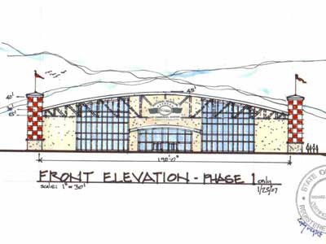
FIGURE 6.
Of course, this is just an estimate based on the description and drawings found in the John C. Robinson proposal. The Board of Directors needs to work with an architect to produce blue prints for a more accurate estimate to be determined.

The Board is facing a serious issue acquiring the parcel of land they wish to build on located at the Gulfport-Biloxi International Airport. They may want to consider other location options. Finding property along the beach is a good idea if the board chooses to consider other possible sites for the museum. Beachfront property would be a huge asset for the museum being located near the casinos. One idea proposed by John McFarland is for the foundation to exhibit the John C. Robinson artifacts at the Ohr-O’Keefe museum, since it is an already established museum. Another idea would be to implement a traveling museum. This would consist of making the exhibits available in different locations on specified dates. Many museums do this to help raise money for their final destination spot and also to get the word out about their museum.

The next main cost associated in opening a museum would be the staff salaries. So far only the Board of Directors has been organized. It is recommended that at least 5 staff members be employed at the start-up of the museum. An idea of these members and their salaries would be an Executive Director ($75k-$100k), Director of Collections ($40k-$50k), Director of Development ($60k-$80k), Operations Manager ($40k-$50k), and an Administrative Aide ($30k-$45k). The number of staff members will be doubled once the museum actually opens its doors. Also, it is beneficial for a museum if the staff begins work at least two years prior to opening. These estimates have been taken from Stephen Watson’s comparisons with the WWII Museum in New Orleans.

Exhibits and artifacts will require a large portion of the start-up funding. It is hard to give a precise estimate for these costs because they will vary depending on the number and quality of exhibits desired. Most of the mid-sized museums have ranged from $100,000 to $300,000 a year for existing exhibits. Exhibit costs can be viewed on the tax form 990’s for each of these museums. From these comparisons, it can be concluded that an appropriate estimate for exhibits and artifacts after initial start-up cost would range from $150,000 to $200,000 a year. During the interview with Stephen Watson, he identified that a plane hanging in the WWII Museum was initially purchased for $200,000, with an additional $200,000 coming from restoration costs. Based on this interview and other data gathered, the Board of Directors can expect to spend a minimum of $750,000 to $1 million on the collection of initial artifacts and exhibits. This number will change depending on the scope of the museum chosen. This would include building the exhibit show areas and maintaining and restoring the artifacts. The foundation should start locating the exhibits and artifacts as soon as possible; as it could take a long time to find certain pieces that may be desired.

The theatre cost will be a large portion of the start-up funding. We have recommended that an IMAX theatre be used in the museum to bring better quality entertainment to the organization. The IMAX theatre would allow the museum to show all of the latest IMAX films. For extra revenue, one may consider showing feature films for members of the community. The National Aviation Museum in Pensacola built an IMAX theatre in 2006 and paid $778,000 for the theatre and the film. The WWII Museum in New Orleans is in the process of building a 4-D theatre, but their figures are closer to $30 million. The costs of the theatre will vary depending on the size and the quality.

Advertising is a cost that may require large sums of money to implement, but advertising is essential to any new organization. Some recommended ways of advertising would be direct mail, newspaper and magazine advertisements, flyers for schools and local businesses and prospective donator packages. There are many other ways in which to advertise that will be discussed in further detail in the marketing section of the business plan.

Other items included in the start-up costs include permits and insurance. The permits will include the building permit, the business or non-profit license and the IRS tax ID number. The insurance will have to include such things as flood, hazard, structure, general liability, and workers compensation. The prices for each will vary depending on who issues the permits and insurance.

The most important aspect of opening a museum is the start-up funding. The Board of Directors should provide a significant amount of the initial funding to get the museum plan and idea out to investors and the general public. According to Mr. Watson, the Board of Directors generally provides a third or more of the start-up funding. A leadership gift is also critical in the first stages of building the museum. The Board of Directors should have a list of people in mind to contribute to the growth of their museum, but one person in general who will provide the major donation and receive the naming rights. A Brick Campaign is an idea the museum should look into to raise money. The Ohr-O’Keefe Museum of Art successfully tried this type of campaign. This is another way of offering naming rights to contributors. The museum could charge varied prices for different levels of brick in order to differentiate status. One of the main priorities of the Board of Director’s should be to encourage investors to donate their money and become a member of the organization.

START-UP COST
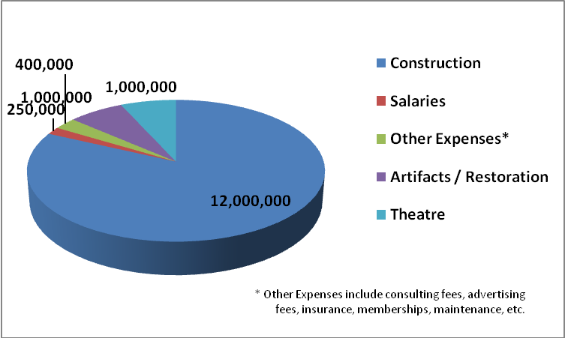
FIGURE 7.

Financials
The financial data compiled for this research came from several sources. The interview with Mr. Stephen Watson was crucial in pointing out the unknown factors involved in the daily operations of a museum, as well as pointing out the key factors important to a non-profit organization. According to Mr. Watson, approximately 80% of the museum’s revenue has to come from contributions. The ticket sales and gift store sales only contribute about 18%. The other 2% generally comes from special events and facility rentals. His figures turn out to be very consistent with all of the other aviation museums that were researched. After collecting financial data from the income tax returns (990’s) of museums of interest, it is clear that contributions make up the largest portion of the revenue.

While compiling the financial data from the income tax returns, phone interviews were conducted with employees from some of the museums. Once data was collected and put into a spreadsheet, it became obvious that there were huge variations in revenue, expenses, visitation, and facility size. By grouping the museums that are comparable to one another, three groups of aviation museums were chosen and the local museums were kept as a separate group. The groups are titled in the data sets as: Local Museums, Small Scale Aviation Museums, Mid-Scale Aviation Museums, and Large Scale Aviation Museums. Projections were based on the Local Museum Group and the Mid-Scale Aviation Museum Group because these are the groups that are the most comparable with what the JCR Foundation envisions for its museum. While examining the local museum information some discrepancies were found in the numbers. After talking with the museum employees, it was realized that these discrepancies were a result of Hurricane Katrina in 2005. The museums had very large contributions and expenses for the 2006 and 2007 years, but no tickets or gift shop sales. This is because these museums are in rebuilding phases. This means that there is probably more willingness to contribute to local rebuilding of the community right now. This is something for the Board of Directors to take into consideration. For research purposes, the financials from previous years for local museums were used in order to capture a more accurate picture of the local trends.

AVERAGE ANNUAL REVENUE
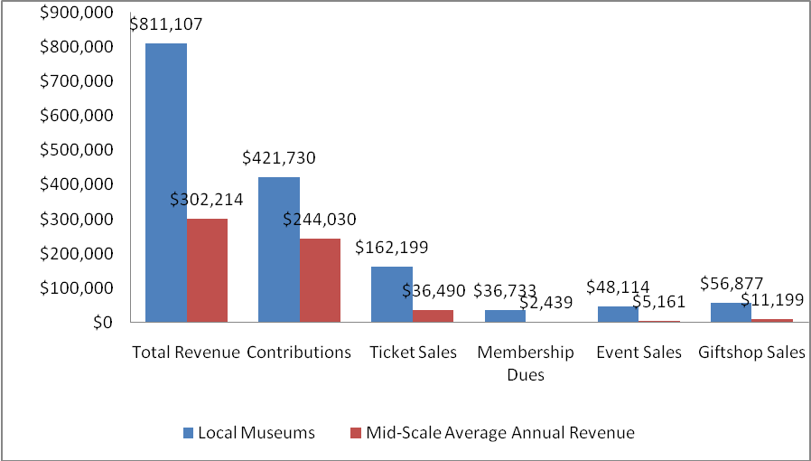
FIGURE 8.

Large Scale Aviation Museums Average Annual Revenue
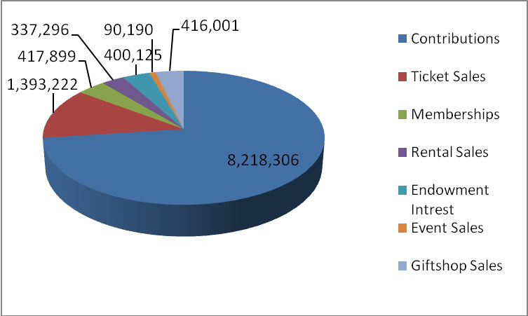
FIGURE 9.

The revenue projections for a 12 month cycle have been calculated by averaging certain categories taken from tax form 990 lines. Line 1e totals the museums contributions, gifts, grants and similar accounts. The contributions that the JCR Museum can expect in the first year would be 332,880 dollars. This averages to 27,740 dollars a month. Line 2 on the 990 provides a total of program service revenue. The projected ticket sales for this museum have been estimated to be 99,344 dollars in the first year. This breaks down to an average of 2,069 visitors a month. If each visitor pays an average of 4 dollars a ticket, the museum will see ticket sales of 8,276 dollars a month. Line 3 on the 990 provides a total of membership dues. The projected revenue from membership dues for this museum is 19,586 dollars in the first year. This number represents an average of 47 membership sales a month at an average price of 35 dollars a membership leading to total monthly membership revenue of 1,645 dollars. Line 6c on the 990 represents rental income. It is estimated that the museum could expect 3,526 dollars a year in rental income with a monthly average of 293 dollars. Line 9c on the 990 represents income from special events. The projected revenue the museum can expect from events is 26,637 dollars a year. This breaks down into an average of 2,220 dollars a month in event revenue. Line 10c totals gross profits of gift store sales. The museum is projected to make 34,038 dollars in the first year from gift store sales. This is an average of 2,837 dollars a month or approximately 1.37 dollars spent per visitor. Air show sales are totaled zero dollar revenue as most often this is a free event. The event itself would however, most likely increase revenues in another sector.

To generate revenue and cost projections that would be pertinent to a project such as the JCR Museum, averages were acquired by combining local and mid-scale museums into one sample set. The 7 year revenue projections represent a steady estimated growth rate of 10 percent. This is calculated for all above categories mentioned and 7 year total revenue is also included.

REVENUE PROJECTIONS
FIGURE 10.

Average Annual Expenses
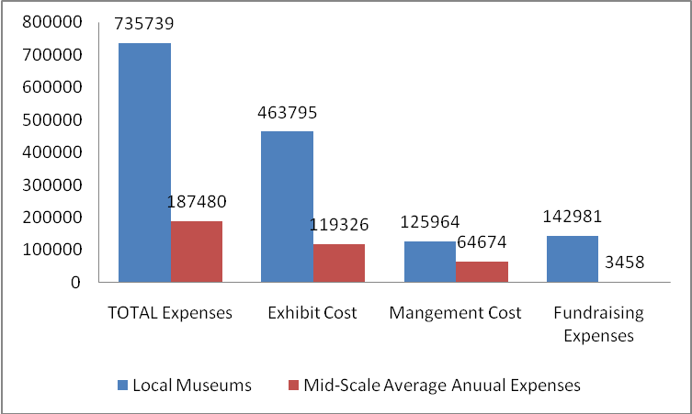
FIGURE 11.

The cost projections for a 12 month cycle have been calculated in the same way revenue projections were calculated. An average was taken from certain categories of the tax form 990. Line 25a totals expense regarding gross wages. The average yearly expense on gross wages is calculated to be 108,273 dollars. This is an average of 9,023 dollars per month in the first year. Line 29 represents expenses related to payroll taxes. The projection for this category is 16,685 dollars in the first year or 1,390 dollars a month. Line 31 is indicative of expenses related to accounting fees. The museum can expect to spend approximately 11,565 dollars in the first year of business. This breaks down to 964 dollars a month in fees. Line 33 totals expenses from supplies. The first year projection is 4,260 dollars or 355 dollars a month. Line 44 totals other expenses. The items in this category vary with the establishment but examples include: dues, development, consulting fees, advertising, etc. The projection for this account is 361,607 dollars in the first year or 30,134 dollars a month.
Twelve-Month Projected Cost
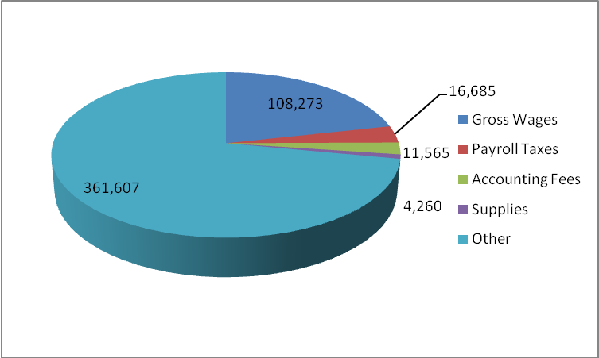
FIGURE 12.
A 7 year cost projection was not completed due to the inability to consistently project cost growth over a given length of time. This growth of costs will depend greatly on the direction and expansion that the JCR Museum takes. The visitation was projected at a 10% steady growth over 7 years. The first year visitation was obtained by taking the average ticket sales across museums and dividing by the average ticket price. The number came out to be 25,000, which has been confirmed to be a realistic goal for the museum in the first year by Stephen Watson.

Annual Visitation Projections
FIGURE 13.
Scope and Limitations
This study entailed extensive research on the museum industry in efforts to better comprehend how the industry operates. The scope of the study consisted of understanding and analyzing data to project cost and revenues for the proposed museum. One of the main limitations was that the study was too broad in nature; therefore it was difficult to be as specific as needed. Another limitation in reference to the local market was the lack of reliable data from the local museums due to the effects of Hurricane Katrina.

Conclusions
In conclusion, there are many issues that have to be considered in the development of a non-profit entity. Given the privately funded nature of museums, it is critical to assess the necessary funding needs associated with the execution of this proposal. The museum board should raise at least 5% of the funds needed for the building in order to receive a loan or grant (Watson). That amounts to about $600,000. The initial funding must come primarily from contributions raised by the Board of Directors. The INFINITY Science Center at NASA has been in the fundraising process for about eight years (McFarland). It is also important to remember that there needs to be funds available to pay salaries to key personnel for several years before the museum actually opens.

Some important decisions need to be made as far as the general type of museum the board desires. If they use mostly artifacts, then there has to be adequate space for storing them safely. Restoration and maintenance of artifacts is one of the largest expenses incurred by museums. If a more media driven style is desired, it could be less expensive and easier to maintain. Another important decision that has to be made is where the museum will be located. If it is located near the airport it may have the advantage of run-way access for air shows and special events. This location may not be to its best advantage however for drawing in tourists. Most of the Gulf Coast tourist attractions tend to be centered on the beachfront near the casinos.

Every decision made by the Board of Directors directly affects the success of the museum. The research presented here was based on general assumptions about the museum. It is strongly recommended that the Board of Directors revisit these forecasts when they have made some concrete decisions concerning the plans for the museum. However, all of the researched data concludes that achieving each of these recommended elements will facilitate the proposed museum’s ability to succeed as a revenue-generating educational institution.

References

American Association of Museums. (2004, December 3). Retrieved June 17, 2008, from http://www.aam-us.org.

Armed Forces Museum Foundation. (n.d). Retrieved July 1, 2008 thru July 20, 2008, from http://www.ngms.state.ms.us/campshelby.

Armed Forces Museum Foundation, Camp Shelby, Ms. IRS 2005 Form 990 – Return of Organization Exempt From Income Tax. (July 1, 2005 thru June 30, 2006). Retrieved July 1, 2008 thru July 20, 2008, from http://www.guidestar.org.

Ayele, Negussay. (2003). African Americans and Ethiopia on the Eve of the Facist Invasion. Ethiopia-American Lifestyle Magazine. Retrieved June 17, 2008, from http://www.tadias.com/v1n7/AE_2_2003-3.html.

Beauvoir, The Jefferson Davis Home and Presidential Library, Biloxi, Ms. IRS 2004 Form 990 – Return of Organization Exempt From Income Tax. (July 1, 2004 thru June 30, 2005). Retrieved July 1, 2008 thru July 20, 2008, from
http://www.guidestar.org.

Briggs, Greg S. P.E., S.E., LEED. (2007). Project Spotlight: New Trends in Museum Development. Retrieved July 16, 2008, from http://www.gostructural.com.

Federation for American Immigration Reform (FAIR). (n.d). Metro Area Factsheet: Biloxi-Gulfport-Pascagoula, Mississippi MSA. Retrieved July 9, 2008 from http://www.fairus.org.

Freeman, Tawanda. (n.d) Air Museum Ready to Take Off. Neighbors Newspapers.Com. Retreived July 8, 2008, from http://www.neighborsnewsparers.com.

Hagerstown Aviation Museum, Hagerstown, Md. IRS 2006 Form 990 – Return of Organization Exempt From Income Tax. (July 1, 2006 thru June 30, 2007). Retrieved July 1, 2008 thru July 20, 2008, from http://www.guidestar.org.

Jones, Christy A. Employee for the Armed Forces Museum Foundation, Interviewed on July 14, 2008.

Marion, Ben. Former Director of the North Carolina Aviation Museum. Interviewed July
14, 2008.

McFarland, John. Marketing Director for the Sun-Herald. Interviewed on July 22, 2008.

Military Aviation Museum of the Pacific, Honolulu Hi. IRS 2006 Form 990 – Return of Organization Exempt From Income Tax. (July 1, 2006 thru June 30, 2007). Retrieved July 1, 2008 thru July 20, 2008, from http://www.guidestar.org.

Miller, Ruth Ellen (n.d). Exhibit Builder Magazine – Online! ‘You Shall Not Harm Your Artifacts’ Museum Trends That Are Challenging. Retrieved July 16, 2008, from http://www.exhibitbuilder.net.

Museum of Aviation Foundation, Inc. (2005) Annual Report.

Museum of Flight Foundation, Seattle, WA. IRS 2005 Form 990 – Return of Organization Exempt From Income Tax. (July 1, 2005 thru June 30, 2006). Retrieved July 1, 2008 thru July 20, 2008, from http://www.guidestar.org.

National Museum of Commercial Aviation. (n.d). Retrieve July 8, 2008, from http://www.nationalaviationmuseum.com/airmuseums-memberships- levels.aspx.

Naval Aviation Foundation, Pensacola, Fl. IRS 2006 Form 990 – Return of Organization Exempt From Income Tax. (July 1, 2006 thru June 30, 2007). Retrieved July 1, 2008 thru July 20, 2008, from http://www.guidestar.org.

North Carolina Aviation Museum. (n.d). Retrieved July 1, 2008 thru July 20, 2008, from http://www.ngairmuseum.org.

North Carolina Aviation Museum, Asheboro, Nc. IRS 2004 Form 990 – Return of Organization Exempt From Income Tax. (July 1, 2004 thru June 30, 2005). Retrieved July 1, 2008 thru July 20, 2008, from http://www.guidestar.org.

Planetware. (n.d). North Carolina Travel Guide, Retrieved July 8, 2008, from htt://planetware.com/north-carolina/Asheboro-us-nc-ashb.html.

Ramos, Rachel T. (2005). Clayton County May Get $12M Air Museum. The Atlanta Business Chronicle. Retrieved July 8, 2008, from http://www.atlanta.bizjournals.com.

Smith, James Ph.D. Professor of History at The University of Southern Mississippi – Long Beach. Interviewed on July 3, 2008 at 1:00PM.

Smith, James Ph.D. Professor of History at The University of Southern Mississippi – Long Beach. Interviewed on July 3, 2008 at 5:10PM.

Southern Museum of Flight, Birmingham, Al. IRS 2006 Form 990 – Return of Organization Exempt From Income Tax. (July 1, 2006 thru June 30, 2007). Retrieved July 1, 2008 thru July 20, 2008, from http://www.guidestar.org.

Thebald, Linda. (2007). Stennis is.…Retrieved July 25, 2008, from
http://www.ssc.NASA.gov.

The Mississippi Department of Education. (2006). Mississippi School District Websites.
Retrieved July 16, 2008, from http://www.mde.k12.ms.us/oetms.htm.

The National World War II Museum, New Orleans, La. IRS 2006 Form 990 – Return of Organization Exempt From Income Tax. (July 1, 2006 thru June 30, 2007). Retrieved July 1, 2008 thru July 20, 2008, from http://www.guidestar.org.

The National World War II Museum. (2007). Annual Report.

The Ohr-O’Keefe Museum of Art, Biloxi, Ms. IRS 2003 Form 990 – Return of Organization Exempt from Income Tax. (July 1, 2003 thru June 30, 2004). Retrieved July 1, 2008 thru July 20, 2008, from http://www.guidestar.org.

The Tennessee Museum of Aviation. (n.d). Retrieved July 1, 2008 thru July 20, 2008, from http://www.tnairmuseum.com.

The Tennessee Museum of Aviation, Sevierville, Tn. IRS 2006 Form 990 – Return of Organization Exempt From Income Tax. (July 1, 2006 thru June 30, 2007). Retrieved July 1, 2008 thru July 20, 2008, from http://www.guidestar.org.
The Walter Anderson Museum of Art, Ocean Springs, Ms. IRS 2006 Form 990 – Return of Organization Exempt From Income Tax. (July 1, 2006 thru June 30, 2007). Retrieved July 1, 2008 thru July 20, 2008, from http://www.guidestar.org.

Tuskegee Airmen National Historic Site. (n.d). Aviation: From Sand Dunes to Sonic Booms. Retrieved July 1, 2008, from http://www.nps.gov.

Wainscott, Grant. Executive Director for the National Museum of Commercial Aviation, Inc. Interviewed July 14, 2008.

Watson, Steve. Vice President and Chief Operating Officer for the National World War II Museum. Interviewed on July 5, 2008.

Western Aerospace Museum. (n.d). Retrieved July 1, 2008 thru July 20, 2008, from http://www.westeraerospacemuseum.org.

Western Aerospace Museum, Oakland, Ca. IRS 2006 Form 990 – Return of Organization Exempt From Income Tax. (July 1, 2006 thru June 30, 2007). Retrieved July 1, 2008 thru July 20, 2008, from http://www.guidestar.org.

Wilmington Aviation Foundation, Wilmington, NC. IRS 2005 Form 990 – Return of Organization Exempt From Income Tax. (July 1, 2005 thru June 30, 2006). Retrieved July 1, 2008 thru July 20, 2008, from http://www.guidestar.org.

